

**The Virtual Filesystem - B**

***Objective: In this lab you explore the*** /proc file system ***and build a LKM that allows a user to read/write to the LKM via it’s*** /proc ***entry.***

***Reference:*** LKI/labs13

In Linux, there is an additional mechanism for the kernel and kernel modules to send information to processes --- the /proc file system. Originally designed to allow easy access to information about processes i.e the name. It is now used by every bit of the kernel which has something interesting to report, such as /proc/modules which provides the list of modules and /proc/meminfo which stats memory usage statistics.

The method to use the proc file system is a structure created with all the information needed for the /proc file, including pointers to any handler functions (in our case there is only one, the one called when somebody attempts to read from the /proc file). Then, init_module registers the structure with the kernel and cleanup_module unregisters it.

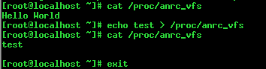

The LKM creates a /proc entry in its initialization. Run the code to read and write to the /proc entry.